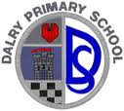 01-12-2017
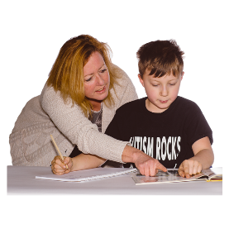
Please come to meet your child’s teacher to find out how they are getting on at school.

On: Monday the 8th of December

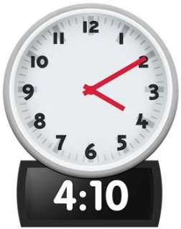
At: 4.10PM

Please phone the school if you cannot make this time.
0131 453 2651

