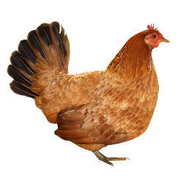
08-12-2017
Your child’s class will be going on a school trip to Gorgie City Farm.
On: Tuesday 16th of December 2017

Your child will need:
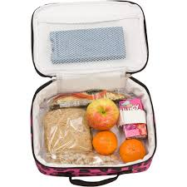
Warm Coat Welly Boots Packed Lunch
Cost: £2.50 by 12th December
-------------------------------------------------------------------------------Please give this part to the teacher with the money
Child’s name:
Yes can go
No can’t go ..........................................
Please find £2.50

