Conference Report
Working together for our children
Saturday 12th March 2018, Dynamic Earth, Edinburgh
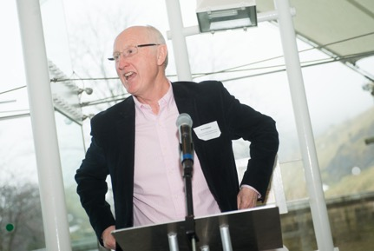
When parents are involved in their children’s learning, it benefits children, families and schools: children do better. This was the main finding of the NPFS Review of the Impact of the Scottish Schools (Parental Involvement) Act 2006. One year on since publishing our review, our 2018 annual conference was a day of parental involvement in action. It gave parents, parent council members, teachers, local authority education staff, policymakers and others the chance to meet, share ideas and learn from each other. As in previous years, the conference was completely free to attend and childcare was provided. 170 delegates registered for the conference (a large increase from 118 at our last conference). 16 children registered for childcare.

NPFS is grateful for the support of Bruce Robertson (Education Policy Advisor and former Director of Education) who chaired the event, delivered the opening and closing sessions, and facilitated the conversation between the keynote speakers and the audience.

The full conference programme, including delegate list, can be viewed here: https://www.npfs.org.uk/wp-content/uploads/2018/03/npfs_conference_programme_2018_E2.pdf.
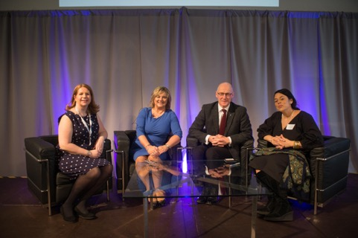
Keynotes were delivered by John Swinney (Deputy First Minister and Cabinet Secretary for Education and Skills), Lindsey Watt (retired headteacher of Castleview Primary School and recipient of the 2017 Robert Owen award) and Marinieves Alba (Community Schools director from Children’s Aid NYC). Bruce Robertson then facilitated a discussion between the keynote speakers and the audience.
Pupils from Castleview Primary School in Edinburgh performed their virtual tour of Craigmillar Castle that was extremely well received:
‘Excellent example of CFE in practice! Amazing kids and staff too.’
‘They were absolutely fantastic and so inspirational.’

A video of the morning session, including British Sign Language (BSL) interpretation, can be viewed here: https://www.youtube.com/watch?v=zjpeCcU9qtg
The feedback on the event was overwhelmingly positive:
‘Thank you for an interesting day. Always good to give parents a voice and a forum from which to operate and be heard!’
‘It was a really rewarding day and both my husband and I were able to attend because of the childcare. We have so many new ideas to take back to the parents council and school.’
‘One of the best conferences I have been to.’
‘Enjoyed it. Worthwhile. Inspirational and relevant speakers always makes it feel worthwhile. Venue, staff and NPF staff were excellent.’
‘Thoroughly enjoyed the conference. Networking and meeting new people was inspiring. Many thanks.’

Workshops
The conference featured a choice of eight workshops (delegates participated in two each) themed around the three strands of the Parental Involvement Act: home / school partnerships, learning at home, and parental representation.

Morning
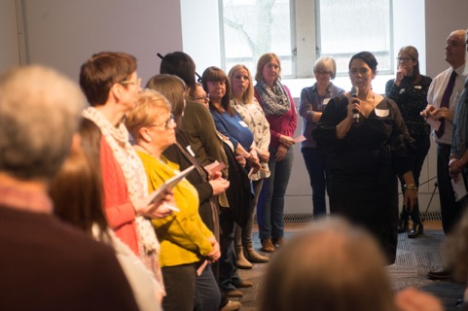
Children’s Aid NYC
This workshop examined strategies for actively engaging parents and other caregivers in the educational life of their children. Focused on cultivating communication, connection, collaboration, and community, this participants explored opportunities for sustained family engagement. It was recognised that schools may need to encourage families to believe in education and that a good teacher can make a critical difference to a pupil and their family. Participants will explore the mindset, resources, and community assets which support caregivers’ active participation and leadership in schools. Together, the participants identified the conditions needed to successfully integrate parents and caregivers into the fabric of school community life. Many solutions were identified to the multitude of barriers we know parents face. These included using a pupil activity to engage parents ; making events that are fun and approachable; healthy cooking clubs also help teach healthy habits; use community locations as school buildings can put parents off; encourage a variety of volunteering as everyone has different skills; focus parents on learning not just fundraising; use money creatively; celebrate success often.
‘It was very thought provoking, and lots of ideas. Excellent workshop’
‘Wonderful opportunity to take us all out of our comfort zones that I definitely feel made it easier to share practice and ideas’
Skills Development Scotland https://www.slideshare.net/Nationalparentforumscot/skills-development-scotland-developing-the-young-workforce
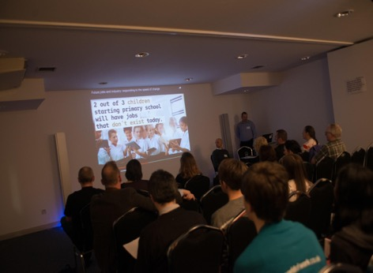
This was an opportunity to hear from Skills Development Scotland (Scotland’s national skills agency) about the support they provide for parents, young people and practitioners to help ensure that thoughts, conversations and decisions about learning and career choices are well informed and reflect the increasingly diverse range of options available to young people in and beyond school. The workshop offered a particular insight into the support available in the parents’ area of the award winning web service My World of Work and about the growing ‘family’ of Scottish apprenticeships ( foundation, modern and graduate). SDS have a Parental Engagement Strategy that has the objectives to better understand parents; help parents understand the influence they have; raise awareness of SDS and its services; and to improve access to high quality careers information and labour market intelligence. Parents learnt about the huge variety of learning pathways now available with continuing life-long learning.
‘Really informative and I will def try to engage our families ‘
‘Guys were excellent. Drove at the heart of the matter , lack of knowledge about what they do and gave us the tools to inform ourselves and others’
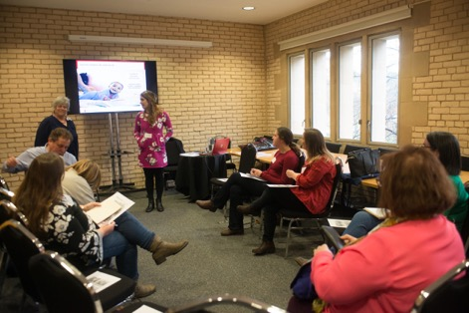
Save the Children https://www.slideshare.net/Nationalparentforumscot/save-the-children-90384037

This workshop was a brief presentation and discussion about the home learning environment, and the opportunities for empowering parents to encourage learning at home and being confident in their role within their child’s learning. Save the Children discussed how learning at home impacts on attachment, bonding and validation. Participants discussed the possible barriers to parents engaging in their childrens’ learning and how the attainment gap could be reduced through effective learning at home.

Respect me
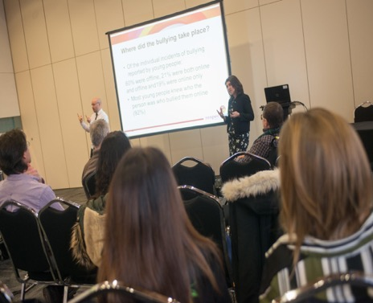
https://www.slideshare.net/Nationalparentforumscot/respect-me-90384256
This workshop offered an overview of the practical skills necessary for parents and carers to support children who are bullied and those who bully others, and also considered the ways in which parents and carers can work alongside schools to influence policies and practices that underpin anti-bullying work. In the last large scale study of bullying in 2014 30% of participants said they had been bullied, and conference delegates thought that the figure may well be higher if such a study was conducted again today. The internet is considered likely to be growing in relevance as a place for bullying behaviour. Conference delegates examined the meaning of bullying; successful teaching about bullying; and the range of behaviours that would constitute bullying. They discussed how parents can help a bullied child and how parents can help a child who is a bully.
Delegate feedback included:
‘Created a floor for great discussion during the workshops’
Father’s Network Scotland
https://www.slideshare.net/Nationalparentforumscot/fathers-network-scotland
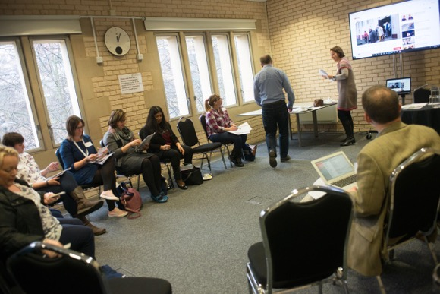
Fathers Network Scotland is working to create a more dad friendly Scotland. Many dads don’t realise what a positive impact they can have on their children’s well-being and development. Schools and nurseries have historically been the domain of women where men are still in the minority. This workshop highlighted the benefits to families & schools of involving dads in education and ways in which schools can actively support dads to be part of their child’s education.
The participants identified barriers such as work commitments, lack of communication, gender spaces and practices and social and structural constraints. However, the perception is that children are keen for dads to be involved, and that whilst ( on the whole) dads have less time with their children they can have an equal impact.
Delegate feedback included:
‘Excellent/ informative/ well delivered ‘
‘Fabulous discussions and lots of useful information and literature and research ‘

Afternoon
Parent Network Scotland
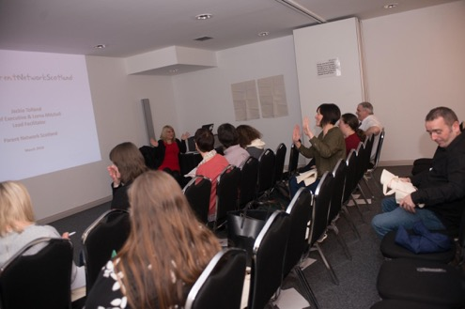
https://www.slideshare.net/Nationalparentforumscot/parent-network-scotland
PNS’ work is based upon the same principle as oxygen masks on airplanes. In other words, PNS helps parents to get the ‘oxygen’ they need themselves first, so they can then: feel more confident (have a greater ‘sense of agency’) about themselves as people; be better prepared for, and supported in, their roles, gain positive experiences in helping each other and their children succeed; and, share their new skills and attitudes to uplift the next group of parents in their community. This workshop looked at the current practice PNS is delivering and how they reach parents who are not already engaged. In particular delegates found value to an interactive session that showed how difficult it can be for people to express what they feel in an open session.
‘Really interesting workshop, engaging presenters really enjoyable ‘
‘Good to find out about an organisation that works so well with parents. They deserve more recognition ‘

Wee Famille
https://www.slideshare.net/Nationalparentforumscot/wee-famille
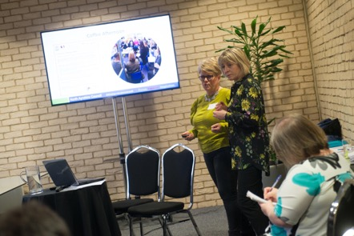
The Wee Famille is a collaboration between SCILT ( the Scottish National centre for Languages), North Ayrshire languages 1+2 team and Springside primary to develop family engagement in languages. It was funded through the attainment challenge and aims to be a sustainable project. In this interactive workshop we will share ho the ‘Wee Famille’ team discussed how they raised the profile of languages and engaged families in learning French with their children. There were many themes common to other projects in the best ways to involve parents: involving food; giving information in advance; a lot of notice given for events; using school social media to remind families; children still got the resources to take home if a family member couldn’t attend; younger children made welcome too.The team also shared with the participants the many cognitive benefits to language learning.
Feedback from delegates included:
‘Fantastique!’
‘Great mix of listening and active participation’
Enquire https://www.slideshare.net/Nationalparentforumscot/pm-enquire-biosphere-blue

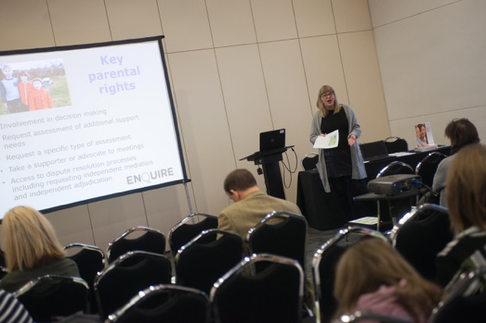

Enquire have been working for over 18 years providing advice and information to families and professionals about additional support for learning. They run a helpline for parents and professionals which receives c.1500 queries a year. In this workshop Cat shared some of the learning from that time about how families of children with additional support needs and school can work well together to ensure children get the support they need. Participants learned about the breadth of ASL - for example it includes children who are very able; children who have suffered a bereavement; children with EAL etc. Participants discussed that parent councils can help parents by asking themselves how their PC can help families to understand ASN. They can act as advocates, provide information and signpost everyone to the services that are available. They can raise awareness as to what constitutes an ASN and help to remove stigma.
Participants also discussed the barriers to communication between schools and families such as second guessing, assuming the worst and being unable to listen ( on both sides the professional and the parent).
‘it has given me a greater awareness of issues which will affect many families across the Scottish Borders. ‘
‘Very informative ‘

Lunchtime Sessions
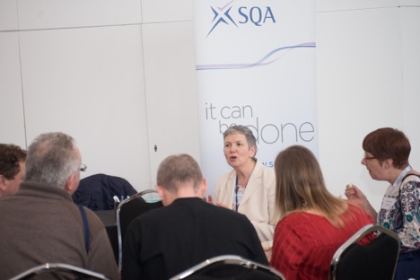
We are grateful to SQA and SCQF for offering informal drop in sessions for parents over the lunch hour. These were very informative for those who attended.
SQA
‘Open and approachable, willing to listen’
‘Very helpful and informative’

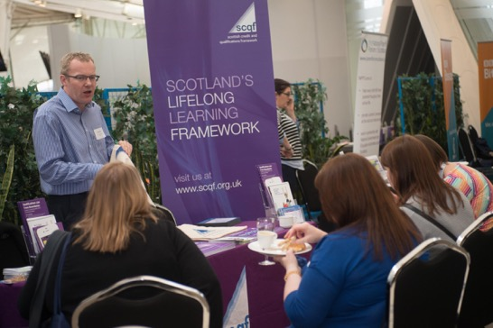

SCQF
‘the chap was hugely enthusiastic and informative ‘
‘Kevin was so friendly and put me at ease right away’

Marketplace
This year we welcomed 25 organisations to our conference marketplace. Feedback this year was extremely positive with the only negative being that delegates would have liked more time to visit.
‘it was excellent ‘
‘I was very impressed. Wish I had had more time. ’
‘Those exhibitors I spoke to were all very engaging and knew their material.’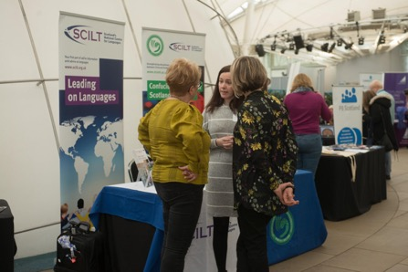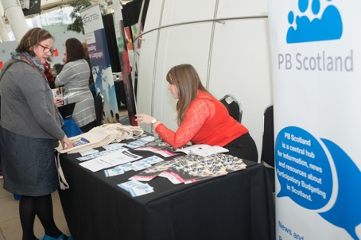
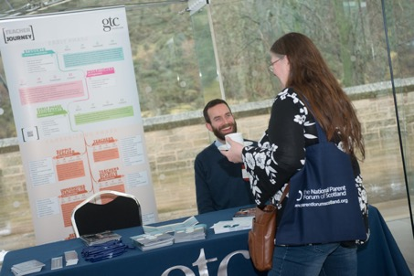
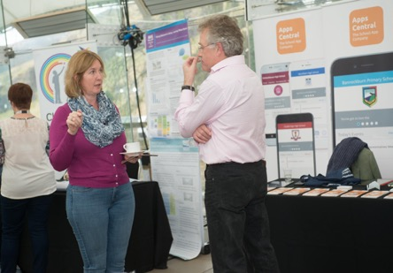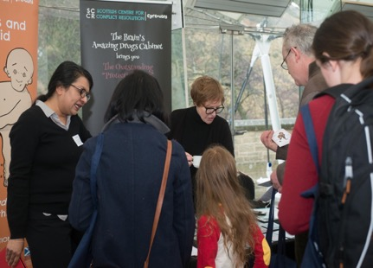
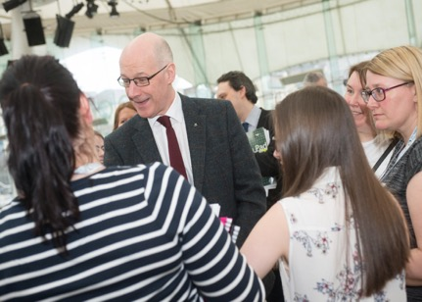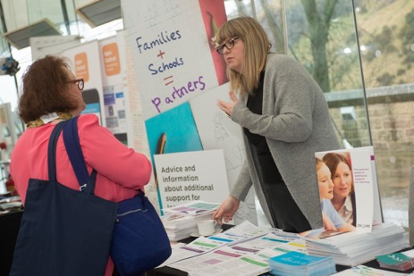
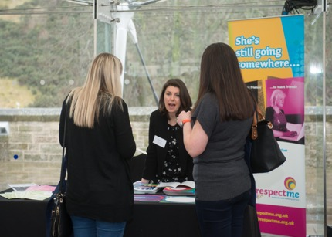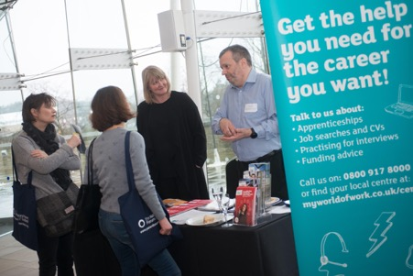
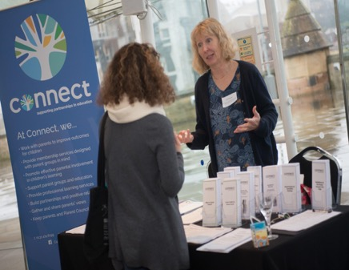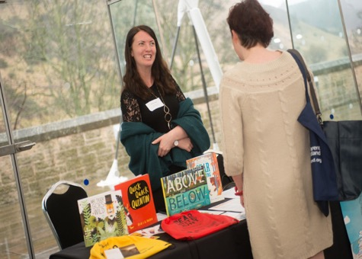
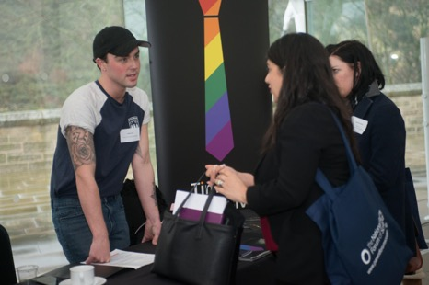

Children’s Programme
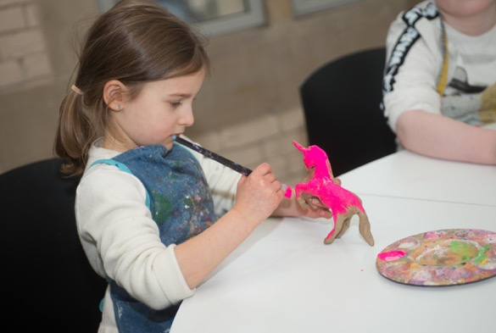
NPFS is an inclusive organisation and as such we provide activities for children of all ages to enable their parents to be able to participate in the conference. This year the children participated in Dynamic Earth’s educational Saturday morning club Dino’s Dynamo’s followed by a tour of Dynamic Earth. In the afternoon there was an arts and crafts session.
‘They both loved it and told us all about icebergs, tree frogs and volcanoes.’
‘Absolutely brilliant, the girls looking after them were brilliant and they had a fantastic time at all the activities ‘

