National Course Design and Assessment  Questions for Parents | 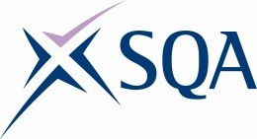

Please return responses to cfe@sqa.org.uk by Friday 29 January 2016.

- Thinking about S1-3:
- How quickly did your child settle into secondary school?
- When subject choices were made, how informed were you about the course choice process?
- How much information you were getting on their progress through Broad General Education (BGE) levels?
- How hard did you feel your child was working in S1-3?
- What sense did you have of their progress through S4, S5, S6 – either from school information, talking to your child, or from media or other information?
- a) Did you feel the demands on them increased as they moved through school?
- What concerns did you have when they were in the Senior Phase (S4-6)?
- Did you feel all subjects were as supportive as others?
- Did your child receive the results they / you / the school expected?

4 a) Did you feel there was a balance of Unit and Course assessment and final external
Assessment in each year in S4-6?
b) Did you feel the step-up from one level to the next – eg N5 to Higher – was as expected?

- a) Have you used the SQA website for information?
- Where do you get other information from?
- Developing Scotland’s Young Workforce
- Are any of your children doing college or vocational type Courses?
- Are there any issues around these and the value they place on these Courses?
- Are there any access issues for your children?
7 Is there anything else you’d like to tell us about your experience of the new National Qualifications or any other SQA qualifications?

