Family Support Project

Survey for parents
 | This survey was written by ENABLE Scotland.
ENABLE want to find out
• what support parents find helpful
• what other support parents need
All the answers you give in this survey are anonymous.
This means people will not be able to tell
who you are from your answers.
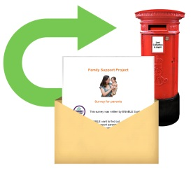 | Thank you for filling in this survey.  Please post it back to:  ENABLE Scotland  Suite H  Riverview House  Perth  PH2 8DF
Questions about you

- Which town do you live in?

- What is your date of birth?

- Who do you live with?

- Do you have a learning difficulty?
Yes
No
Please tell us more…

Questions about your family

- How many children do you have?
1
2
3
More than 3

- How old is your child?
If you have more than 1 child,
please write their ages in different boxes.

- Is your child a boy or a girl?
If you have more than 1 child, please tick more boxes.
Child 1 Child 2 Child 3
Boy
Girl
Boy
Girl
Boy
Girl

Questions about support

- Who from your family and friends helps you
with your child?
 | Family members
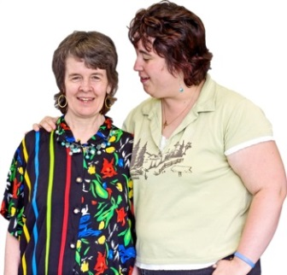 | Friends
 | Other parents

Please tell us about anyone else who helps you…

- What kind of help do they give you?
 | Advice
Practical help –
an extra pair of hands
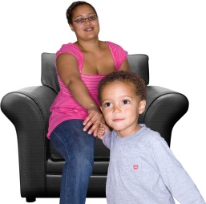 | Looking after my child when I am away
 | Getting around

Please tell us about anything else they help you with…

- Which professional people help you with your child?
Support worker
Doctor
Social worker
People at school

Please tell us about anyone else who helps you…

- What kind of help do they give you?
 | Advice
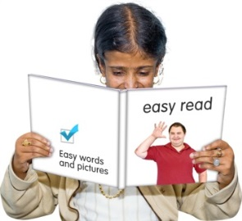 | Information like leaflets
 | Classes

Please tell us about anything else they help you with…

- Which tasks do you manage on your own?
 | Housework
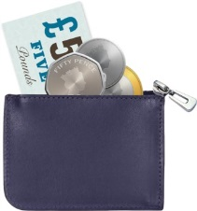 | Dealing with money
 | Dealing with school or nursery
 | Getting around
 | Feeding my child
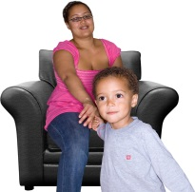 | Looking after my child

Please tell us about anything else you manage
on your own…

- Is there anything you feel you need help with?
Housework
Dealing with money
Dealing with school or nursery
Getting around
Feeding my child
Looking after my child

Please tell us about anything else you feel you
need help with…

- What kind of extra support would you find helpful?
Advice
Information like leaflets
Practical help – an extra pair of hands
Help to deal with money
Help getting around

Please tell us about anything else you would find
helpful…

- Has anyone really helped you with your child or children?

Yes No

If you said yes, who helped you?

What did they do to help you?

One last question…
- What are your hopes and dreams for you and your family?

You can write words or draw a picture.

This is the end of the survey.
Thank you for filling it in!

